

**Milestone 2**



\

By: Patrick Dempsey, Jeanine Buonopane, & Kevin Le

**1.1 Context Diagram**

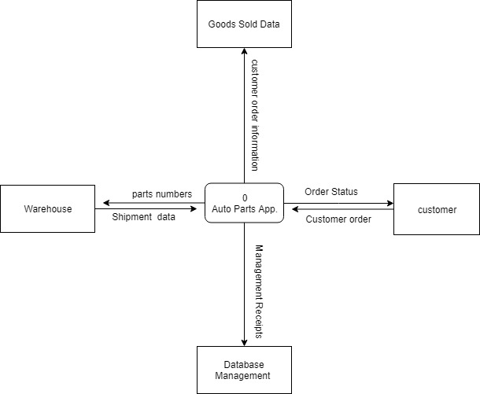

**1.2 Level 0 Diagram**

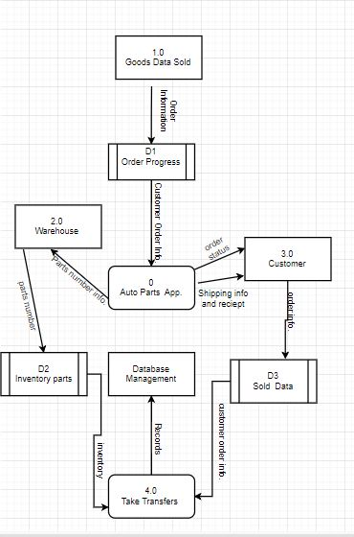

**1.3 Leveled Diagrams**

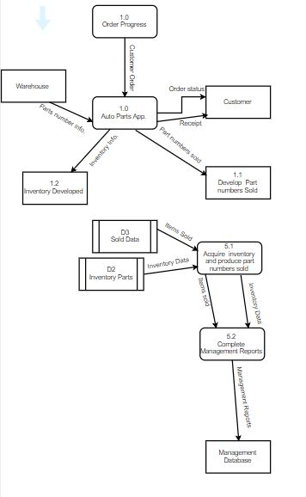

**Level 2**

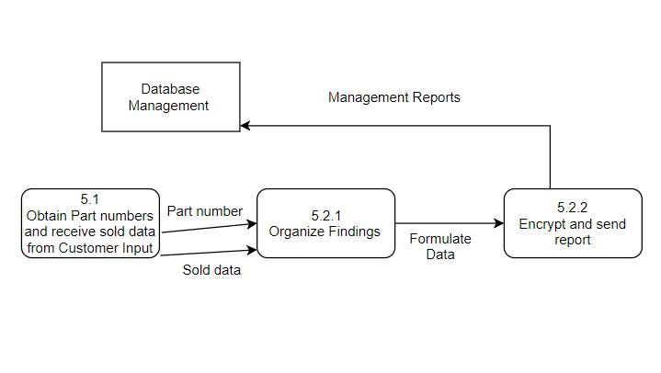

**2.0 Entity Relationship Diagrams**

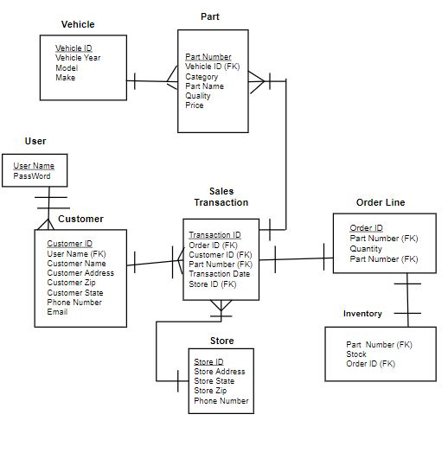

**3.0 Data Dictionary**

